|  |  |  |  |  |  |  |  |  |
| --- | --- | --- | --- | --- | --- | --- | --- | --- |
| **TABLE OF CONTENT** | | | | | | | | |
| **CHAPTER NO** | **CHAPTER** | | | | | | | **PAGE**  **NO** |
|  | **ABSTRACT** | | | | | | |  |
| **LIST OF FIGURES** | | | | | | |  |
| **LIST OF ABBREVIATION** | | | | | | |  |
|  | **INTRODUCTION** | | | | | | |  |
|  |  |  | Project Objectives | | | | |  |
|  |  | Embedded System Implementation | | | | |  |
|  | |  | | Implementation Flow | | |  |
|  |  | |  | |  | | |  |
|  | **LITERATURE SURVEY** | | | | | | |  |
|  |  | | | | | | |  |
|  | **SYSTEM ANALYSIS** | | | | | | |  |
|  |  |  | Existing System | | | | |  |
|  |  | Proposed System | | | | |  |
|  |  |  |  | | | | |  |
|  | **SYSTEM DESIGN** | | | | | | |  |
|  |  |  | Block Diagram | | | | |  |
|  |  |  | Block Diagram Description | | | | |  |
|  |  |  | Requirement Specification | | | | |  |
|  |  |  |  | | | | |  |
|  | **SYSTEM REQUIREMENT** | | | | | | |  |
|  |  |  | Requirement Specification | | | | |  |
|  |  |  | Hardware Requirement | | | | |  |
|  |  |  |  | Microcontroller | | | |  |
|  |  |  |  |  | | | Introduction to Arduino UNO |  |
|  |  |  |  |  | | | Pin Description: |  |
|  |  |  |  |  | | | Arduino UNO Technical Specification |  |
|  |  |  |  | Gas sensor (MQ2) | | | |  |
|  |  |  |  | IR sensor | | | |  |
|  |  |  |  | Ultrasonic Sensor | | | |  |
|  |  |  |  | Flow Sensor | | | |  |
|  |  |  |  |  | | Working Principal | |  |
|  |  |  |  | GSM module | | | |  |
|  |  |  |  | LCD | | | |  |
|  |  |  |  | DHT11 Sensor | | | |  |
|  |  |  |  | Buzzer | | | |  |
|  |  |  |  | Power supply / Rectifier | | | |  |
|  |  |  |  |  | | | |  |
|  |  |  | Software Requirement | | | | |  |
|  |  |  |  | Arduino IDE | | | |  |
|  |  |  |  | Programed by C | | | |  |
|  |  |  |  |  | | | |  |
|  | **CONCLUSION** | | | | | | |  |
|  |  | | | | | | |  |
|  | **FUTURE SCOPE** | | | | | | |  |
|  |  | | | | | | |  |
|  | **REFERENCE** | | | | | | |  |
|  |  |  |  | | | | |  |
|  |  |  |  | | | | |  |

**ABSTRACT**

A smart city is the future goal to have cleaner and better for the society. Smart underground infrastructure is an important feature to be considered while implementing a smart city. Drainage system monitoring plays a vital role in keeping the city clean and healthy. Since manual monitoring is incompetent, this leads to slow handling of problems in drainage and consumes more time to solve. To mitigate all these issues, the system using a wireless sensor network, consisting of sensor nodes is designed.The system also provides a real-time alert to the relevant authorities, enabling them to take immediate action The proposed system is low cost, low maintenanceInternet of Things (IoT) devices, and artificial intelligence algorithms based real-time which alerts the managing station through an email/message when any manhole crosses its threshold values and to check whether a manhole cap is open or closed. This system reduces the death risk of manual scavengers who clean the underground drainage and also benefits the public.

**LIST OF FIGURES**

|  |  |  |
| --- | --- | --- |
| **FIGURE NO** | **NAME OF THE FIGURES** | **PAGE NO** |
| 1.1 | Overview of Embedded System |  |
| 1.2 | Flow Of Burning Source Code To Processor |  |
| 3.1 | Proposed System Architecture |  |
| 5.1 | Arduino UNO |  |
| 5.2 | Arduino board & ATmega328P MC |  |
| 5.3 | Atmega328 Microcontroller pin Diagram |  |
| 5.4 | Arduino Pinout |  |
| 5.5 | **MQ2 Sensor** |  |
| 5.6 | Various Parts of a Gas Sensor |  |
| 5.7 | Hexapod Structure inside a Gas Sensor |  |
| 5.8 | Closer Look at the Ceramic Element |  |
| 5.9 | IR Sensor |  |
| 5.10 | Ultrasonic Sensor |  |
| 5.11 | HC-SR04 Ultrasonic Sensor - Working |  |
| 5.12 | Flow Sensor |  |
| 5.13 | Working Of Flow Sensor |  |
| 5.14 | GSM Module |  |
| 5.15 | LCD – Front View |  |
| 5.16 | LCD – Back View |  |
| 5.17 | Pin Diagram |  |
| 5.18 | DHT11 Sensor |  |
| 5.19 | Buzzer |  |
| 5.20 | Circuit of rectifier |  |
| 5.21 | Arduino IDE interface |  |
|  |  |  |

**LIST OF ABBREVIATION**

|  |  |
| --- | --- |
| **IOT** | Internet Of Things |
| **GSM** | Global System For Mobile Communication |
| **AI** | Artificial Intelligence |
| **ML** | Machine Learning |
| **AVR** | Alf And Vegard's Risc Processor |
| **IR** | Infrared |
| **DHT11** | Digital Humidity And Temperature |
| **LCD** | Liquid-Crystal Display |
| **HVAC** | Heating, Ventilation, And Air Conditioning |
| **AC** | Alternating Current |
| **DC** | Direct Current. |
| **IDE** | Integrated Development Environment |

1. **INTRODUCTION**

An integral part of any drainage system is the access points into it when it comes to cleaning, clearing, and inspection. Metropolitan cities have adopted underground drainage systems, and the city’s municipal corporation must maintain cleanliness. If the sewage maintenance is not proper, groundwater gets contaminated causing infectious diseases. Blockages in drains during monsoon season cause problems in the routine of the public. Hence, there should be a facility in the city’s corporation, which alerts the officials about blockages in sewers, and their exact location. It mainly acknowledges in the field of alerting the people about gas explosions on, increases in the water level and temperature level. It uses IoT to make the drainage monitoring system in a highly automotive by using sensors for detecting and sending alerts through GSM to the authorities. This project overcomes the demerits by detecting drainage water blockage by installing water flow rate sensors at the intersection of nodes. When there is a blockage in a particular node, there is variation in the flow of drainage water which when crosses the set value will display the alert in the managing station. Also, other demerits are solved by detecting temperature variations inside the manhole and alerting the same to the managing station. Also, flow rate sensors are used to detect the overflow of the drainage water and alerting the same to the managing station through automatic messages.

**1.1 Project Objectives**

The project’s primary objective is to develop a system that can monitor manhole covers in real-time. The system should be able to detect and measure parameters such as liquid flow, object presence, and liquid level in the manhole. Additionally, the project aims to develop a system that can trigger alerts in case of any issues with the manhole cover. This includes generating SMS alerts to concerned authorities and an audible alert through a buzzer. The platform should provide a user interface for authorized personnel to monitor and control the system. The project also aims to integrate IoT edge computing into the Smart Cities Manhole Cover Management System. This includes using an Arduino board to process data collected by the sensors, triggering alerts, and communicating with other components of the system.

Furthermore, the project aims to design the Smart Cities Manhole Cover Management System with future scalability in mind. This includes exploring the potential for AI and ML integration, cloud integration, and block chain integration. The system should be designed in a way that enables easy integration with these technologies in the future. The overall project objectives are to develop a comprehensive system that can monitor and manage manhole covers in real time, reduce downtime, improve efficiency, and prevent accidents. The system should be scalable, easy to use, and provide remote monitoring and control capabilities.

* 1. **Embedded System Implementation**

An embedded system is one kind of a computer system mainly designed to perform several tasks like to access, process, and store and also control the data in various electronics-based systems. Embedded systems are a combination of hardware and software where software is usually known as firmware that is embedded into the hardware. One of its most important characteristics of these systems is, it gives the o/p within the time limits. Embedded systems support to make the work more perfect and convenient. So, we frequently use embedded systems in simple and complex devices too. The applications of embedded systems mainly involve in our real life for several devices like microwave, calculators, TV remote control, home security and neighbourhood traffic control systems, etc.

**Bringing software and hardware together for embedded system:**

To make software to work with embedded systems we need to bring software and hardware together .for this purpose we need to burn our source code into microprocessor or microcontroller which is a hardware component and which takes care of all operations to be done by embedded system according to our code.



Fig 1.1: Overview of Embedded System

Generally we write source codes for embedded systems in assembly language, but the processors run only executable files. The process of converting the source code representation of your embedded software into an executable binary image involves three distinct steps:

* Each of the source files must be compiled or assembled into an object file.
* All of the object files that result from the first step must be linked together to produce a single object file, called the re-locatable program.
* Physical memory addresses must be assigned to the relative offsets within the re-locatable program in a process called relocation.

The result of the final step is a file containing an executable binary image that is ready to run on the embedded system.

**1.2.1 Implementation Flow:**

**Stage 1:**

Considering the problems of existing methods and giving solution to that problem by considering the basic requirements for our proposed system

**Stage 2:**

Considering the hardware requirement for the proposed system

For this we need to select the below components:

1. Microcontroller

2. Inputs for the proposed system ( sensors, drivers etc..,)

3. Outputs (Buzzer , loads..)

**Stage 3:**

After considering hardware requirements, now we need to check out the software requirements. Based on the microcontroller we select there exists different software for coding, compiling, debugging. we need to write source code for that proposed system based on our requirements and compile, debug the code in that software .

After completing all the requirements of software and hardware we need to bring both together to work our system. For this we need to burn our source code into microcontroller, after burning our source code to microcontroller then connect all input and output modules as per our requirement.



Fig 1.2: Flow of burning source code to processor

1. **LITERATURE SURVEY**
2. **Xinru Fu ‘Manhole Cover Intelligent Detection And Management System’ Journal of Atlantis Press , 2016**

This paper presents the design and implementation of manhole cover system. In order to avoid the risks that imperfect manhole cover and feature to bring, this paper, aiming at the existing problem of manhole cover, proposed a detectable and maintainable regionalization covers intelligent security management system. Many sensors set up in the manhole cover to real-time monitor its situation, Through MCU?RF Wireless Data Communication Module and upper computer to understand and control manhole cover, this system could monitor the city manhole cover in real time and give an alarm automatically. There is no double that it could improve the management ability of the manhole cover and greatly enhance the safety of people’s travel.

1. [**N Nataraja**](https://ieeexplore.ieee.org/author/37088221332)**;**[**R Amruthavarshini**](https://ieeexplore.ieee.org/author/37088219486)**;**[**N L Chaitra**](https://ieeexplore.ieee.org/author/37088213913)**;**[**K Jyothi**](https://ieeexplore.ieee.org/author/37088220368)**;**[**N Krupaa**](https://ieeexplore.ieee.org/author/37088216051)**;**[**S S M Saqquaf**](https://ieeexplore.ieee.org/author/37086088815) **‘Secure Manhole Monitoring System Employing Sensors and GSM Techniques’ Published in:**[**2018 3rd IEEE International Conference on Recent Trends in Electronics, Information & Communication Technology (RTEICT)**](https://ieeexplore.ieee.org/xpl/conhome/8977133/proceeding)

In this paper implementation of Opening of manholes due to breakage of manhole cover, manhole explosions are major threat in recent days. Manhole cover opening leads to accidental fall of vehicles, pedestrians leading to accidents or loss of life. Manhole opening detection and alerting is mainly based on detecting the manholes which are opened due to overflow of sewage / rain water during heavy rainfall and alerting. When a manhole opening is detected either due to overflow of sewage water, increase in pressure or temperature, it leads to the breakage of the manhole lids. To avoid such incidents even before it could affect the public, an alerting system is built wherein the buzzer alerts the surrounding and sends the sensed data to the managing authorities using GSM techniques. So, they can take precautionary action to close the manhole considering public safety.

1. **Dr.T.Menakadevi , Akash.M , Dilip kumar.B , Kannan.M , Chandra Mohan.S ‘IOT BASED AUTOMATED MANHOLE DETECTION’published in International Research Journal of Engineering and Technology (IRJET) , 2021**

A smart city is the future goal to have cleaner and better amenities for the society. Smart underground infrastructure is an important feature to be considered while implementing a smart city. Drainage system monitoring plays a vital role in keeping the city clean and healthy. Since manual monitoring is incompetent, this leads to slow handling of problems in drainage and consumes more time to solve. To mitigate all these issues, the system using a wireless sensor network, consisting of sensor nodes is designed. The proposed system is low cost, low maintenance IoT based real time which alerts the managing station through an email when any manhole crosses its threshold values. This system reduces the death risk of manual scavengers who clean the underground drainage and also benefits the public.

# **Amit Mankotia, Anil Kumar Shukla ‘IOT based manhole detection and monitoring system using Arduino’ Department of ECE, ASET, Amity University Uttar Pradesh, Noida, India. Published in science direct, 2022.**

contamination of fresh water due to problem in sewage drainage system is of concern. In observation most of the manhole’s lids were not in the settled emplacement. As most of the manhole’s lids are in the damaged condition. Because of the damaged manholes, there are chances of occurrence of accidents on the road. These damaged manholes will be hazard to the personal safety. The goal of this project is to create an effective accident-avoidance system by avoiding open manholes in large cities. Sensors such as tilt sensors are used to identify rifts and damage to manhole lids, and the information obtained is then sent to the authorities of the municipal corporation department and the councillor of the local region, who will find the manhole location. The supervision and the maintenance are done through the Internet of Things. The working and implementation of this project will be very useful to the society.

# [**S. Sundararajan**](https://ieeexplore.ieee.org/author/37089345532)**;**[**R. Santhana Krishnan**](https://ieeexplore.ieee.org/author/37088822550)**;**[**B. Sumathi**](https://ieeexplore.ieee.org/author/37089418474)**;**[**D. Rachel**](https://ieeexplore.ieee.org/author/37089417216)**;**[**N. Iswarya**](https://ieeexplore.ieee.org/author/37089418866)**;**[**K. Manju**](https://ieeexplore.ieee.org/author/37089418649) **‘Solar based Manhole Surveillance System (SMSS)’ Published in:** [**6th International Conference on Intelligent Computing and Control Systems (ICICCS)**](https://ieeexplore.ieee.org/xpl/conhome/9788085/proceeding)**, 2022.**

Proper maintenance and periodical monitoring of manholes will help us to maintain good hygiene in the society. Improper maintenance will lead to loss of life, the spread of disease in the community and a lot more issues. A lot of sewers lost their lives while encountering poisonous gases during the process of cleaning and this death rate seems to be increasing every year. In addition to this manhole lid is kept open which also leads to a lot of accidents. To bring a better solution to these existing issues, this research work has proposed a system named Solar based Manhole Surveillance System (SMSS). The proposed SMMS system will monitor the gases inside the manhole and forwards an alert message to the municipality via a cloud server. Similarly, the level of sewage is closely observed and that information will be passed to the municipality and the nearby public. The unwanted movement of the manhole lid is identified and that information will be passed to the municipality. In addition to this, the whole system is operated with the support of a solar power supply which reduces the usage of electricity to a huge extent.

**3. SYSTEM ANALYSIS**

1. **Existing System**

Today’s manhole systems is not high-tech. So whenever there is blockage it is difficult to figure out the exact location of the blockage. Also, early alerts of the blockage are not received. Hence detection and repairing of the blockage become time consuming. It becomes very inconvenient to handle the situation when pipes are blocked completely and garbage cleaning. Due to such failure of drainage line and overflow of garbage people face a lot of problems. The existing system also lacks real-time data and insights that could be useful in optimizing city services such as traffic management, waste management, and public safety. With the IoT Edge-Computing-based system, city officials can use the data collected by the sensors to monitor and improve city services.

1. **Proposed System**

In the proposed method, development of IoT based drainage and manhole monitoring system is designed. This system monitors temperature, manhole lid position whether it will opened or close. Maximum levels are set and sensors keep monitoring the changing conditions. As the levels reach a maximum set point the sensors detect and send the signal to controller, where it commands the IoT network to generate alerts to the “Municipal Corporation”. Gas sensor will monitor the toxic gases, Flow sensor will detect the Flow rate of the manhole water, hence the water flow blockage is also easily detected. DHT11 sensor will monitor the Temperature and humidity. If any of the sensor data increases greater than the threshold value then GSM (Global System for Mobile Communication) will send the message to Municipal Corporation and the buzzer will give alerts.

In This proposed solution user doesn’t need to have internet access in his device to get updates from this manhole Monitoring & detection system

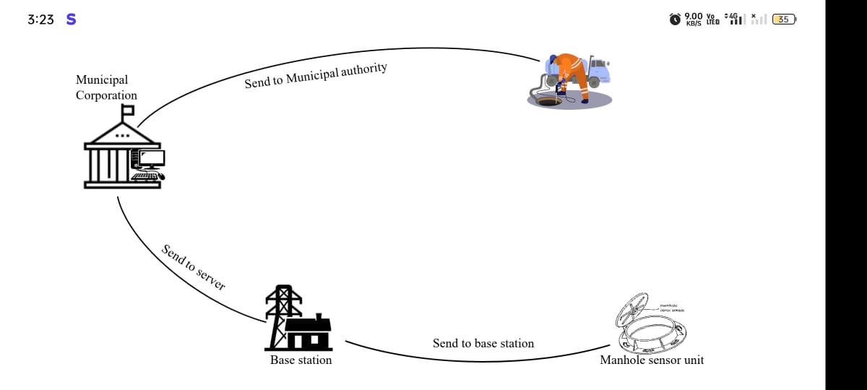

Fig 3.1: Proposed System Architecture

1. **SYSTEM DESIGN**
2. **Block Diagram**

Arduino

UNO

IR Sensor

Ultrasonic

Sensor

Flow Sensor

Gas Sensor

DHT11

GSM module sim800c

LCD

Cloud Server

Power Supply

Mobile

1. **Block Diagram Description**

The Smart Cities Manhole Cover Management System based on IoT edge computing is a comprehensive system designed to monitor and manage manhole covers in real-time. The system is made up of various components that work together seamlessly to detect and measure different parameters such as the flow of water, Whether the lead open/close using IR sensor, water level , and harmful gases . The data collected by the sensors is processed by an Arduino board, which acts as the central controller for the system. The Arduino board is responsible for analysing the data, triggering alerts, and communicating with other components of the system. In case of any issues with the manhole cover, a GSM module is used to send SMS alerts to concerned authorities, and a buzzer is used to generate an audible alert. The system is connected to a cloud-based platform, which enables remote monitoring and control of the system.

1. **SYSTEM REQUIREMENT**
2. **Requirement Specification**

The requirements specification is a technical specification of requirements for the software products. It is the first step in the requirements analysis process it lists the requirements of a particular software system and hardware system including functional, performance and requirements. The requirements also provide usage scenarios from a user, an operational and an administrative perspective. The purpose of software requirements specification is to provide a detailed overview of the software project, its parameters and goals. This describes the project target doctor and the patient interface, hardware and software requirements. It defines how the patient, doctor see the system and its functionality.

1. **Hardware Requirements**
   * 1. **Microcontroller**
        1. **Introduction To Arduino UNO**

* **Arduino Uno** is a microcontroller board developed by Arduino.cc which is an open-source electronics platform mainly based on AVR microcontroller Atmega328.
* First Arduino project was started in Interaction Design Institute Ivrea in 2003 by David Cuartielles and Massimo Banzi with the intention of providing a cheap and flexible way to students and professional for controlling a number of devices in the real world.
* The current version of Arduino Uno comes with USB interface, 6 analog input pins, 14 I/O digital ports that are used to connect with external electronic circuits. Out of 14 I/O ports, 6 pins can be used for PWM output.
* It allows the designers to control and sense the external electronic devices in the real world

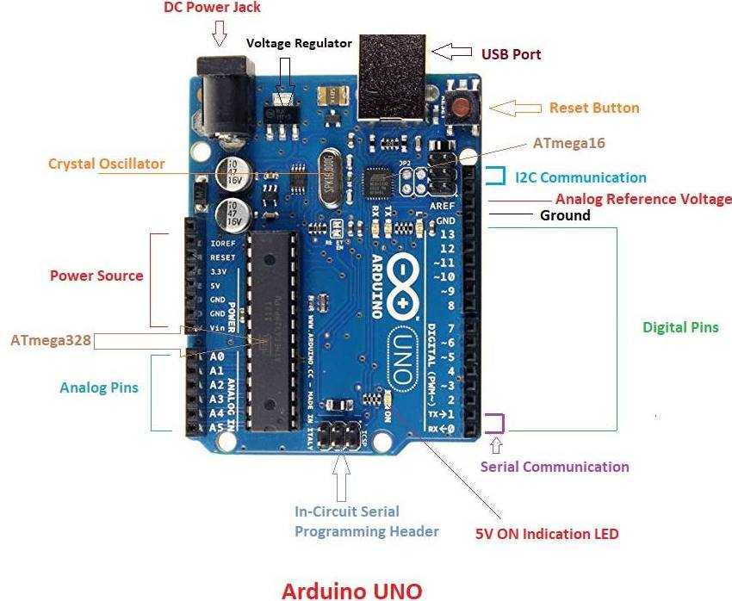

Fig 5.1: Arduino UNO

* This board comes with all the features required to run the controller and can be directly connected to the computer through USB cable that is used to transfer the code to the controller using IDE (Integrated Development Environment) software, mainly developed to program Arduino. IDE is equally compatible with Windows, MAC or Linux Systems, however, Windows is preferable to use. Programming languages like C and C++ are used in IDE.
* Apart from USB, battery or AC to DC adopter can also be used to power the board.
* Arduino Uno boards are quite similar to other boards in Arduino family in terms of use and functionality, however, Uno boards don’t come with FTDI USB to Serial driver chip.
* There are many versions of Uno boards available, however, Arduino Nano V3 and Arduino Uno are the most official versions that come with Atmega328 8-bit AVR Atmel microcontroller where RAM memory is 32KB.
* When nature and functionality of the task go complex, Mirco SD card can be added in the boards to make them store more information.
* The software used for Arduino devices is called IDE (Integrated Development Environment) which is free to use and required some basic skills to learn it. It can be programmed using C and C++ language.

In the Smart Cities Manhole Cover Management System based on IoT edge computing, an Arduino board is used to process data collected by the sensors. The board is responsible for triggering alerts and communicating with other components of the system. The Arduino board is connected to sensors such as flow sensors, IR sensors, and ultrasonic sensors that collect data on liquid flow, object presence, and liquid level in the manhole.

The data collected by the sensors is then processed by the Arduino board, which triggers alerts if any issues are detected with the manhole cover. The Arduino board communicates with other components of the system, such as the GSM module, which is responsible for sending SMS alerts to concerned authorities. The use of Arduino in the Smart Cities Manhole Cover Management System enables real-time data processing, reduces latency, and improves the overall efficiency and effectiveness of the system.

Overall, Arduino plays a critical role in the Smart Cities Manhole Cover Management System, enabling the system to collect, process, and communicate data in real-time. Its versatility, ease of use, and affordability make it an ideal choice for IoT-based projects such as this one.

Some people get confused between **Microcontroller and Arduino**. While former is just an on system 40 pin chip that comes with a built-in microprocessor and later is a board that comes with the microcontroller in the base of the board, bootloader and allows easy access to input-output pins and makes uploading or burning of the program very easy.

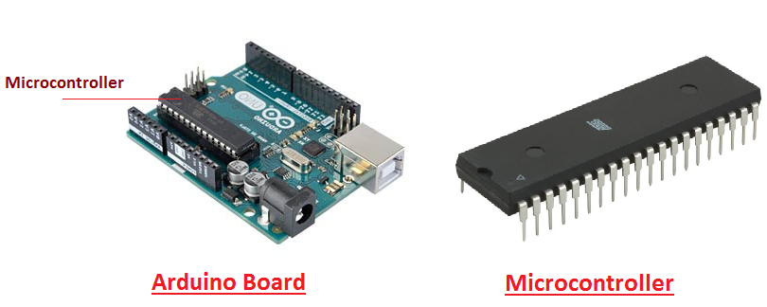

Fig 5.2: Arduino board & ATmega328P MC

**Arduino Pinout**

* Arduino Uno is based on AVR microcontroller called Atmega328. This controller comes with 2KB SRAM, 32KB of flash memory, 1KB of EEPROM. Arduino Board comes with 14 digital pins and 6 analog pins. ON-chip ADC is used to sample these pins. A 16 MHz frequency crystal oscillator is equipped on the board. Following figure shows the pinout of the Arduino Uno Board

.

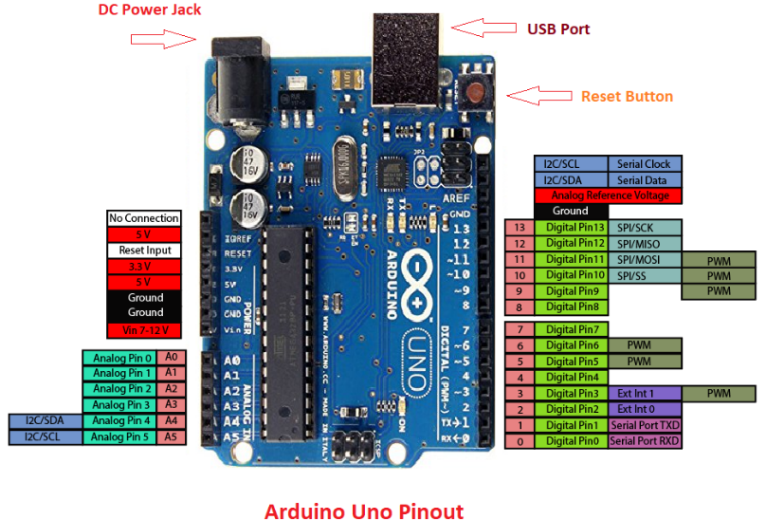

**Fig 5.4: Arduino Pinout**

* + - 1. **Pin Description**

There are several I/O digital and analog pins placed on the board which operates at 5V. These pins come with standard operating ratings ranging between 20mA to 40mA. Internal pull-up resistors are used in the board that limits the current exceeding from the given operating conditions. However, too much increase in current makes these resisters useless and damages the device.

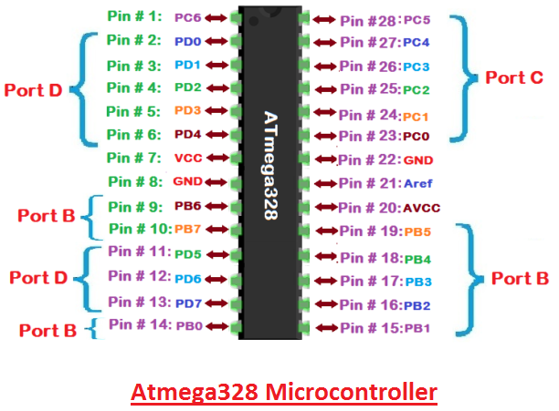

**Fig 5.3: Atmega328 Microcontroller pin Diagram**

**LED:**  Arduino Uno comes with built-in LED which is connected through pin 13. Providing HIGH value to the pin will turn it ON and LOW will turn it OFF.

**Vin:** It is the input voltage provided to the Arduino Board. It is different than 5 V supplied through a USB port. This pin is used to supply voltage. If a voltage is provided through power jack, it can be accessed through this pin.

**5V:** This board comes with the ability to provide voltage regulation. 5V pin is used to provide output-regulated voltage. The board is powered up using three ways i.e. USB, Vin pin of the board, or DC power jack.

**GND:** These are ground pins. More than one ground pins are provided on the board which can be used as per requirement.

**Reset:**  This pin is incorporated on the board which resets the program running on the board. Instead of a physical reset on the board, IDE comes with a feature of resetting the board through programming.

**IOREF:** This pin is very useful for providing voltage reference to the board. A shield is used to read the voltage across this pin which the selects the proper power source.

**PWM:**  PWM is provided by 3, 5, 6,9,10, 11pins. These pins are configured to provide 8-bit output PWM.

**SPI:**  It is known as Serial Peripheral Interface. Four pins 10(SS), 11(MOSI), 12(MISO), 13(SCK) provide SPI communication with the help of SPI library.

**AREF:** It is called Analog Reference. This pin is used for providing a reference voltage to the analog inputs.

**TWI:**  It is called Two-wire Interface. TWI communication is accessed through Wire Library. A4 and A5 pins are used for this purpose.

**Serial Communication:** Serial communication is carried out through two pins called Pin 0 (Rx) and Pin 1 (Tx). Rx pin is used to receive data while Tx pin is used to transmit data.

**External Interrupts:**  Pin 2 and 3 are used for providing external interrupts. An interrupt is called by providing LOW or changing value.

### **Arduino Uno Technical Specifications**

|  |  |
| --- | --- |
| Microcontroller | [ATmega328P](https://components101.com/microcontrollers/atmega328p-pinout-features-datasheet) – 8 bit AVR family microcontroller |
| Operating Voltage | 5V |
| Recommended Input Voltage | 7-12V |
| Input Voltage Limits | 6-20V |
| Analog Input Pins | 6 (A0 – A5) |
| Digital I/O Pins | 14 (Out of which 6 provide PWM output) |
| DC Current on I/O Pins | 40 mA |
| DC Current on 3.3V Pin | 50 mA |
| Flash Memory | 32 KB (0.5 KB is used for Bootloader) |
| SRAM | 2 KB |
| EEPROM | 1 KB |
| Frequency (Clock Speed) | 16Hz |

* + 1. **MQ2 SENSOR**

The **gas sensor module** consists of a steel exoskeleton under which a sensing element is housed. This sensing element is subjected to current through connecting leads. This current is known as heating current through it, the gases coming close to the sensing element get ionized and are absorbed by the sensing element. This changes the resistance of the sensing element which alters the value of the current going out of it.

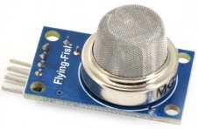

***Fig 5.5:MQ2 Sensor***

**The MQ2 sensor is a gas sensor that can detect different types of gases such as smoke, propane, methane, and carbon monoxide. It is a popular sensor used in various electronic projects and is especially useful in detecting gas leaks and fires. In the Smart Cities Manhole Cover Management System based on IoT edge computing, the MQ2 sensor can be used to detect the presence of toxic gases in the manhole. Toxic gases can pose a threat to workers who may need to enter the manhole for maintenance or repairs.**

**The MQ2 sensor can be connected to the Arduino board in the Smart Cities Manhole Cover Management System and can be used to trigger an alert in case of any toxic gas presence in the manhole. This alert can be in the form of an audible alarm, an SMS alert sent to concerned authorities, or both.**

**The use of the MQ2 sensor in the Smart Cities Manhole Cover Management System improves the safety of workers and reduces the risk of accidents. It also ensures that any toxic gas presence is detected in real-time, allowing prompt action to be taken to prevent any harm.**

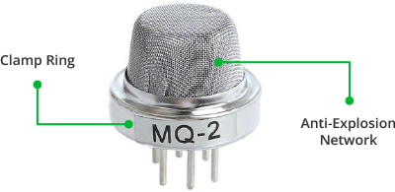

***Fig 5.6: Various Parts of a Gas Sensor***

Fig 5.5 shows externals of a standard gas sensor module: a steel mesh, copper clamping ring and connecting leads. The top part is a stainless steel mesh which takes care of the following:

1. Filtering out the suspended particles so that only gaseous elements are able to pass to insides of the sensor.

2. Protecting the insides of the sensor.

3.  Exhibits an anti-explosion network that keeps the sensor module intact at high temperatures and gas pressures.

The top of the gas sensor is removed off to see the internals parts of the sensor: sensing element and connection wiring. The hexapod structure is constituted by the sensing element and six connecting legs that extend beyond the Bakelite base.

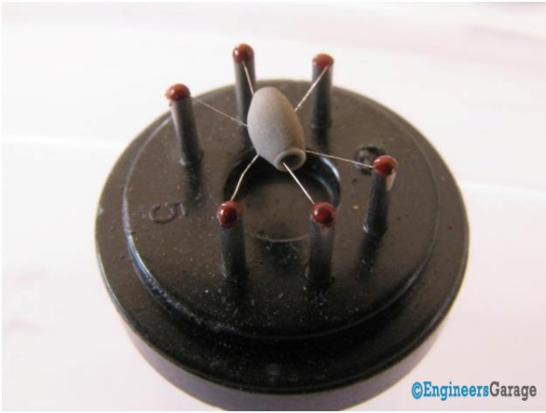

**Fig 5.7: Hexapod Structure inside a Gas Sensor**

The hollow sensing element which is made up from Aluminum Oxide based ceramic and has a coating of tin oxide. Using a ceramic substrate increases the heating efficiency and tin oxide, being sensitive towards adsorbing desired gas’ components (in this case methane and its products) suffices as sensing coating.

The leads responsible for heating the sensing element are connected through Nickel-Chromium, well known conductive alloy. Leads responsible for output signals are connected using platinum wires which convey small changes in the current that passes through the sensing element.  The platinum wires are connected to the body of the sensing element while Nickel-Chromium wires pass through its hollow structure.

While other wires are attached to the outer body of the element, Nickel-Chromium wires are placed inside the element in a spring shaped. Image 5 shows coiled part of the wire which is **placed on the inside of the hollow ceramic.**

**MQ2 sensor has a sensitivity range of 300-10,000 ppm for propane and a sensitivity range of 200-10,000 ppm for methane. The sensitivity range for smoke and carbon monoxide is in the range of a few hundred parts per million (ppm).**

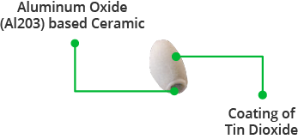

**Fig 5.8: Closer Look at the Ceramic Element**

The ceramic with tin dioxide on the top coating that has good adsorbing property Fig 5.8 . Any gas to be monitored has specific temperature at which it ionizes. The task of the sensor is to work at the desired temperature so that gas molecules get ionized. Through Nickel-chromium wire, the ceramic region of the sensing element is subjected to heating current. The heat is radiated by the element in the nearby region where gases interact with it and get ionized. Once, ionized, they are absorbed by the tin dioxide. Adsorbed molecules change the resistance of the tin dioxide layer. This changes the current flowing through the sensing element and is conveyed through the output leading to the unit that controls the **working of the gas sensor**.

* + 1. **IR Sensor**

An IR (infrared) sensor is a device that can detect infrared radiation in its surrounding environment. It is a popular sensor used in various electronic projects due to its low cost and versatility.

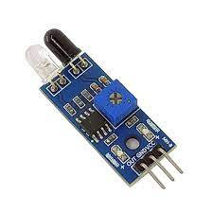

***Fig 5.9: IR Sensor***

IR sensor can also be used in the Smart Cities Manhole Cover Management System to detect the presence of the manhole lead. The manhole lead is a metallic plate that covers the manhole and is used to secure the manhole cover.

The IR sensor can be installed on the underside of the manhole cover and can detect the presence of the manhole lead when it comes in close proximity to the sensor. This can be done by setting up the IR sensor to detect a specific wavelength of light that is reflected off the metallic surface of the manhole lead. can be used to trigger an alert in case the manhole lead is missing or damaged. This alert can be in the form of an audible alarm, an SMS alert sent to concerned authorities, or both.

The system ensures that any missing or damaged manhole lead is detected in real-time, allowing prompt action to be taken to repair or replace it. This improves the safety of pedestrians and drivers, reducing the risk of accidents caused by open manhole covers.

* + 1. **Ultrasonic Sensor**

An ultrasonic sensor transmit ultrasonic waves into the air and detects reflected waves from an object. There are many applications for ultrasonic sensors, such as in intrusion alarm systems, automatic door openers and backup sensors for automobiles.

Accompanied by the rapid development of information processing technology, new fields of application, such as factory automation equipment and car electronics, are increasing and should continue to do so. Using its unique piezoelectric ceramics manufacturing technology developed over many years, Murata has developed various types of ultrasonic sensors which are compact and yet have very high performance. The information contained in this catalog will help you to make effective use of our ultrasonic sensors.

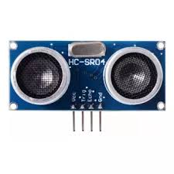

***Fig 5.10: Ultrasonic Sensor***

The ultrasonic sensor can be placed at the top of the manhole and pointed downwards towards the water level. When the sensor emits sound waves, they travel down to the water level and bounce back up to the sensor. The time taken for the sound waves to travel to the water level and back up to the sensor can be used to calculate the distance between the sensor and the water level, which can then be used to determine the water level. The ultrasonic sensor can be connected to the Arduino board in the Smart Cities Manhole Cover Management System and can be used to trigger an alert in case of high water levels inside the manhole. This alert can be in the form of an audible alarm, an SMS alert sent to concerned authorities, or both.

The use of an ultrasonic sensor to measure the water level in the Smart Cities Manhole Cover Management System ensures that the water level inside the manhole is monitored in real-time, allowing prompt action to be taken to prevent flooding and damage to the manhole and surrounding areas. It also improves the safety of workers and reduces the risk of accidents.

**HC-SR04 Ultrasonic Sensor - Working**

As shown above the HC-SR04 Ultrasonic (US) sensor is a 4 pin module, whose pin names are Vcc, Trigger, Echo and Ground respectively. This sensor is a very popular sensor used in many applications where measuring distance or sensing objects are required. The module has two eyes like projects in the front which forms the Ultrasonic transmitter and Receiver. The sensor works with the simple high school formula that

**Distance = Speed × Time**

The Ultrasonic transmitter transmits an ultrasonic wave, this wave travels in air and when it gets objected by any material it gets reflected back toward the sensor this reflected wave is observed by the Ultrasonic receiver module as shown in the picture below

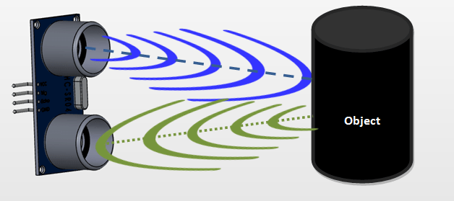

***Fig 5.11: HC-SR04 Ultrasonic Sensor - Working***

Now, to calculate the distance using the above formulae, we should know the Speed and time. Since we are using the Ultrasonic wave we know the universal speed of US wave at room conditions which is 330m/s. The circuitry inbuilt on the module will calculate the time taken for the US wave to come back and turns on the echo pin high for that same particular amount of time, this way we can also know the time taken. Now simply calculate the distance using a microcontroller or microprocessor.

* + 1. **Flow Sensor**

A flow sensor (more commonly referred to as a “[flow meter](https://realpars.com/how-flow-meters-work/)”) is an electronic device that measures or regulates the flow rate of liquids and gasses within pipes and tubes. Flow sensors are generally connected to gauges to render their measurements, but they can also be connected to computers and digital interfaces. They are commonly used in HVAC systems, medical devices, chemical factories, and septic systems. Flow sensors are able to detect leaks, blockages, pipe bursts, and changes in liquid concentration due to contamination or pollution.

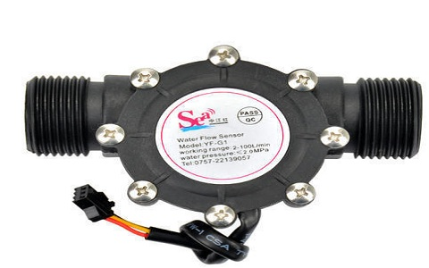

***Fig 5.12: Flow Sensor***

Flow sensors can be divided into two groups: contact and non-contact flow sensors. Contact flow sensors are used in applications where the liquid or gas measured is not expected to become clogged in the pipe when it comes into contact with the sensor’s moving parts. In contrast, non-contact flow sensors have no moving parts, and they are generally used when the liquid or gas (generally a food product) being monitored would be otherwise contaminated or physically altered by coming into contact with moving parts.

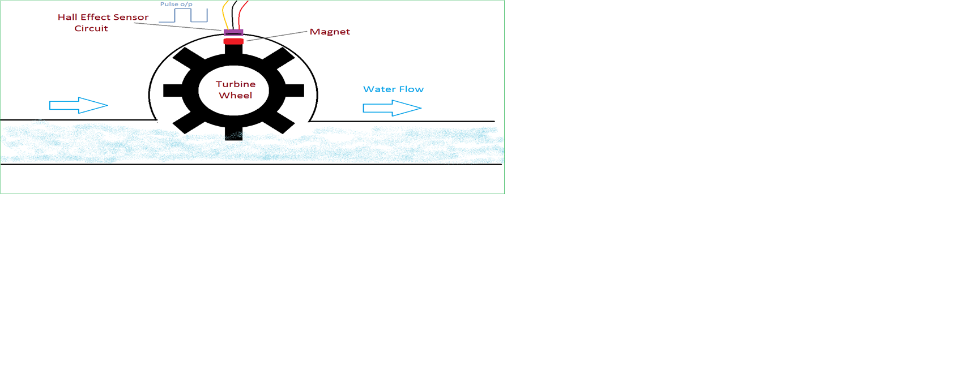

***Fig 5.13: Working Of Flow Sensor***

A flow sensor is a device that is used to measure the rate of flow of a fluid in a pipeline or channel. A flow sensor can be used to detect the flow of sewage water inside the manhole. The flow sensor can be installed in the pipeline that leads to the manhole and can be connected to the Arduino board in the Smart Cities Manhole Cover Management System. The flow sensor can measure the rate of flow of the sewage water inside the pipeline and can send this data to the Arduino board.

The Arduino board can then analyze this data to determine the flow of sewage water inside the manhole. If the flow rate is above a certain threshold, it can trigger an alert in the form of an audible alarm, an SMS alert sent to concerned authorities, or both.

# **GSM Module**

GPRS Modules are one of the commonly used communication modules in embedded systems. A GPRS Module is used to enable communication between a microcontroller (or a microprocessor) and the GPRS Network. Here, GSM stands for Global System for Mobile Communication and GPRS stands for General Packet Radio Service.

A GPRS MODEM comprises of a GPRS Module along with some other components like communication interface (like Serial Communication – RS-232), power supply and some indicators. With the help of this communication interface, we can connect the GSM GPRS Module on the GPRS MODEM with an external computer (or a microcontroller).

GPRS Modules allow microcontrollers to have a wireless communication with other devices and instruments. Such wireless connectivity of microcontroller opens up to wide range of applications like Home Automation, Home Security Systems, Disaster Management, Medical Assistance, Vehicle Tracking, Online Banking, E – Commerce etc. to name some.

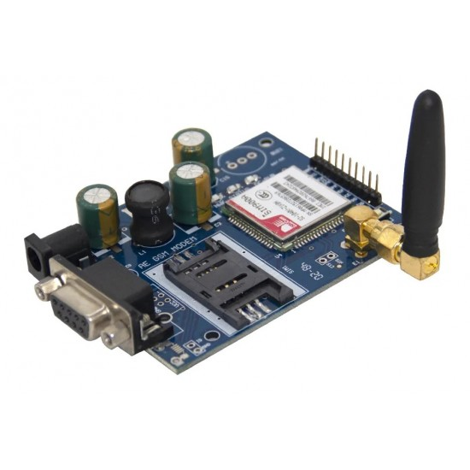

***Fig 5.14: GSM Module***

The GSM module can be connected to the Arduino board in the Smart Cities Manhole Cover Management System and can be programmed to send SMS alerts to the phone numbers of concerned authorities in case of any anomalies detected by the sensors. This can include alerts for high water levels, low manhole cover pressure, or any other issues that require immediate attention.

The use of a GSM module in the Smart Cities Manhole Cover Management System ensures that concerned authorities are immediately notified of any issues detected by the sensors. This allows prompt action to be taken to resolve the issue before any major damage occurs. It also ensures that the system is always monitored, even when concerned authorities are not physically present at the location.

**Execution Command**:

These commands perform an operation like send an SMS, retrieving information about battery charging status etc. They read the non – variable subparameters that are affected by the GSM Module.

Syntax of Execution Commands: ATCMD1<CR>

Example for Execution Commands: AT+CMGS=<number><CR> <text message> <CTRL-Z> (Sends text message to the number).

### Information Responses and Final Codes

After sending the AT Commands to the GSM GPRS Module, we have look for the response. For example, if we send the command as AT+CGMI<CR> to the GSM Module, then the response would be as follows.

<CR><LF>Apple<CR><LF>

<CR><LF>OK<CR><LF>

Here, <CR> is Carriage Return and <LF>is Line Feed.

In a HyperTerminal, if you entered AT+CGMI<CR>, the response will look something like this.

AT+CGMI <– Command entered

Apple <– Information Response

OK <– Final Code

The syntax of the information response and final command is as follows:

<Carriage Return><Line Feed> <Information Response / Final Result Code> <Carriage Return><Line Feed>

<CR><LF><Response><CR><LF>

***NOTE***: The sequence of execution of commands will be first commands, then second command, followed by the rest i.e. a sequential execution of commands.

If there is an error anywhere in the execution, an error code is returned by the GSM Module and the execution of further commands is terminated.

### Frequently used AT Commands

In this list, you can find out some of the most commonly used AT Commands. For a complete list of AT Commands and their definitions, it is advised to refer the manufacturer data. The <Carriage Return> or <CR> is denoted by this symbol ↲.

**To check the communication between the GSM Module and the host (Computer)**

AT ↲

OK

**To make a voice call**

ATD6380607370; ↲

**To answer or receive an incoming call**

ATA ↲

**To redial the last number**

ATDL ↲

**To disconnect a call**

ATH ↲

**To set the message mode to text mode**

AT+CMGF=1 ↲

OK

**To send a text message**

AT+CMGS=”6380607370” ↲

Message

* + 1. **LCD**

LCD (Liquid Crystal Display) is the innovation utilized in scratch pad shows and other littler PCs. Like innovation for light-producing diode (LED) and gas-plasma, LCDs permit presentations to be a lot more slender than innovation for cathode beam tube (CRT). LCDs expend considerably less power than LED shows and gas shows since they work as opposed to emanating it on the guideline of blocking light.

A LCD is either made with a uninvolved lattice or a showcase network for dynamic framework show. Likewise alluded to as a meager film transistor (TFT) show is the dynamic framework LCD. The uninvolved LCD lattice has a matrix of conductors at every crossing point of the network with pixels. Two conductors on the lattice send a current to control the light for any pixel. A functioning framework has a transistor situated at every pixel crossing point, requiring less current to control the luminance of a pixel. Some aloof network LCD's have double filtering, which implies they examine the matrix twice with current in the meantime as the first innovation took one sweep. Dynamic lattice, be that as it may, is as yet a higher innovation.

A 16x2 LCD show is an essential module that is generally utilized in various gadgets and circuits. These modules more than seven sections and other multi fragment LEDs are liked. The reasons being: LCDs are affordable; effectively programmable; have no restriction of showing exceptional and even custom characters (not at all like in seven fragments), movements, etc.

[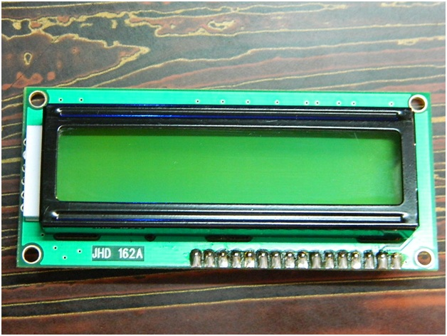](http://www.circuitstoday.com/wp-content/uploads/2012/02/LCD-Display-Front-Side.jpg)

***Fig 5.15: LCD – Front View***

[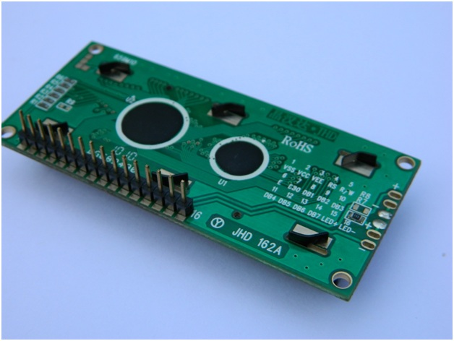](http://www.circuitstoday.com/wp-content/uploads/2012/02/lcd-display-back-side.jpg)

***Fig 5.16: LCD – Back View***

**Pin Diagram:**

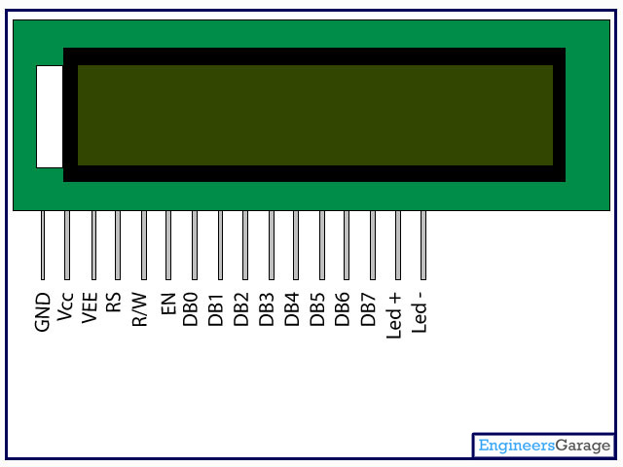

***Fig 5.17: Pin Diagram***

**Pin Description:**

|  |  |  |
| --- | --- | --- |
| Pin No | Function | Name |
| 1 | Ground (0V) | Ground |
| 2 | Supply voltage; 5V (4.7V – 5.3V) | Vcc |
| 3 | Contrast adjustment; through a variable resistor | VEE |
| 4 | Selects command register when low; and data register when high | Register Select |
| 5 | Low to write to the register; High to read from the register | Read/write |
| 6 | Sends data to data pins when a high to low pulse is given | Enable |
| 7 | 8-bit data pins | DB0 |
| 8 | DB1 |
| 9 | DB2 |
| 10 | DB3 |
| 11 | DB4 |
| 12 | DB5 |
| 13 | DB6 |
| 14 | DB7 |
| 15 | Backlight VCC (5V) | Led+ |
| 16 | Backlight Ground (0V) | Led- |

* + 1. **DHT11 SENSOR**

The DHT11 is a basic, low-cost digital temperature and humidity sensor. It uses a capacitive humidity sensor and a thermistor to measure the surrounding air, and spits out a digital signal on the data pin (no analog input pins needed). It’s fairly simple to use, but requires careful timing to grab data. The only real downside of this sensor is you can only get new data from it once every 2 seconds.

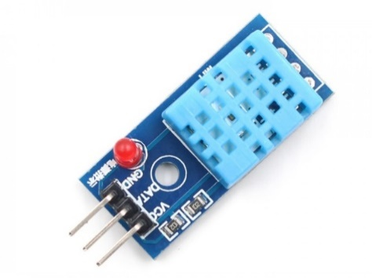

***Fig 5.18: DHT11 Sensor***

## **Technical Specifications:**

|  |  |  |  |  |  |
| --- | --- | --- | --- | --- | --- |
| Item | Measurement  Range | Humidity  Accuracy | Temperature Accuracy | Resolution | Package |
| DHT11 | 20-90%RH  0-500C | ±5％RH | ±20C | 1 | 4 Pin Single Row |

In the Smart Cities Manhole Cover Management System based on IoT edge computing, the DHT11 sensor can be used to monitor the temperature and humidity inside the manhole. Extreme temperatures and humidity levels can pose a risk to workers who may need to enter the manhole for maintenance or repairs. The DHT11 sensor can be connected to the Arduino board in the Smart Cities Manhole Cover Management System and can be used to trigger an alert in case of extreme temperature or humidity levels inside the manhole. This alert can be in the form of an audible alarm, an SMS alert sent to concerned authorities, or both.

The use of the DHT11 sensor in the Smart Cities Manhole Cover Management System ensures that temperature and humidity levels inside the manhole are monitored in real-time, allowing prompt action to be taken to prevent any harm. It also improves the safety of workers and reduces the risk of accidents.

**Power and Pin:**

DHT11’s power supply is 3-5.5V DC. When power is supplied to the sensor, do not send any instruction to the sensor in within one second in order to pass the unstable status. One Capacitor valued 100nF can be added between VDD and GND for power filtering.

* + 1. **Buzzer**

A buzzer or beeper is an audio signalling device, which may be mechanical, electromechanical, or piezoelectric. Typical uses of buzzers and beepers include alarm devices, timers and confirmation of user input such as a mouse click or keystroke. Buzzer is an integrated structure of electronic transducers, DC power supply, widely used in computers, printers, copiers, alarms, electronic toys, automotive electronic equipment, telephones, timers and other electronic products for sound devices. Active buzzer 5V Rated power can be directly connected to a continuous sound, this section dedicated sensor expansion module and the board in combination, can complete a simple circuit design, to "plug and play.

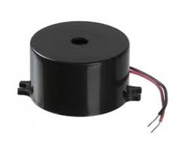

***Fig 5.19: Buzzer***

**Buzzer Pin Configuration**

|  |  |  |
| --- | --- | --- |
| **Pin Number** | **Pin Name** | **Description** |
| 1 | Positive | Identified by (+) symbol or longer terminal lead. Can be powered by 5V DC |
| 2 | Negative | Identified by short terminal lead. Typically connected to the ground of the circuit |

* + 1. **Power supply**

**Rectifier:**

A **rectifier** is an electrical device that [converts](https://en.wikipedia.org/wiki/Electric_power_conversion) [alternating current](https://en.wikipedia.org/wiki/Alternating_current) (AC), which periodically reverses direction, to [direct current](https://en.wikipedia.org/wiki/Direct_current) (DC), which flows in only one direction. The process is known as *rectification*, since it "straightens" the direction of current.

Rectifiers have many uses, but are often found to serve as components of DC power supplies and direct power transmission systems with high voltage. Rectification can be used in roles other than direct current generation for use as a power source.

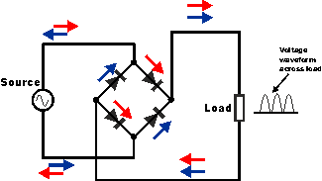

***Fig 5.20: Circuit of rectifier***

* 1. **Software Requirement**
     1. **Arduino IDE:**

**Arduino IDE**where IDE stands for Integrated Development Environment – An official software introduced by Arduino.cc, that is mainly used for writing, compiling and uploading the code in the Arduino Device. Almost all Arduino modules are compatible with this software that is an open source and is readily available to install and start compiling the code on the go.

* Arduino IDE is an open source software that is mainly used for writing and compiling the code into the Arduino Module.
* It is an official Arduino software, making code compilation too easy that even a common person with no prior technical knowledge can get their feet wet with the learning process.
* It is easily available for operating systems like MAC, Windows, and Linux and runs on the Java Platform that comes with inbuilt functions and commands that play a vital role for debugging, editing and compiling the code in the environment.
* A range of Arduino modules available including Arduino Uno, Arduino Mega, Arduino Leonardo, [Arduino Micro](https://www.theengineeringprojects.com/2018/09/introduction-to-arduino-micro.html) and many more.
* Each of them contains a microcontroller on the board that is actually programmed and accepts the information in the form of code.
* The main code, also known as a sketch, created on the IDE platform will ultimately generate a Hex File which is then transferred and uploaded in the controller on the board.
* The IDE environment mainly contains two basic parts: Editor and Compiler where former is used for writing the required code and later is used for compiling and uploading the code into the given Arduino Module.
* This environment supports both C and C++ languages.

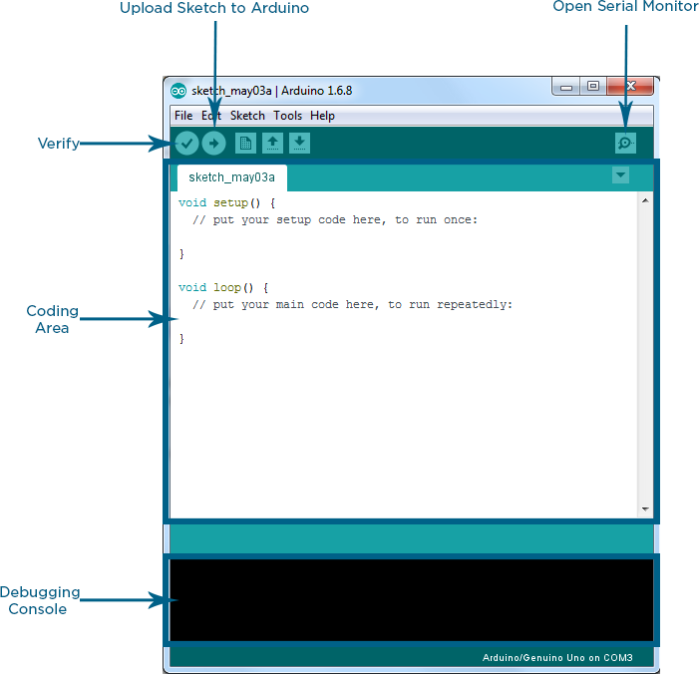

***Fig 5.21: Arduino IDE Interface***

* + 1. **Programed by C/C++**

This System can be programmed using the Arduino Integrated Development Environment (IDE), which uses the C/C++ programming language. C is a high-level programming language that is used for system programming, embedded systems, and developing applications. The code for the Smart Cities Manhole Cover Management System can be written in C using the Arduino IDE, and it can be compiled and uploaded to the Arduino board using the IDE. The C code can be used to read data from the sensors, control the flow of data through the system, and send alerts and notifications when required.

In addition to the C language, the Arduino IDE also includes a range of libraries and examples that can be used to simplify the programming process and speed up development time. These libraries include functions for controlling the sensors, communicating with the GSM module, and controlling the buzzer, among others.

**FUTURE SCOPE**

1. Machine Learning: Incorporating machine learning algorithms to the system can improve its efficiency and accuracy in detecting issues with the manhole cover. By analyzing data collected over time, machine learning models can predict potential problems before they occur.
2. Energy Harvesting: Using energy harvesting technologies such as solar panels or kinetic energy harvesting can power the sensors and devices used in the system. This can reduce the dependence
3. Artificial Intelligence (AI) Integration: AI algorithms can be integrated with the system to analyze the data collected by the sensors and provide insights on trends and patterns.
4. **CONCLUSION**

The Manhole monitoring needs to be cleaned when it is filled to maintain a hygienic environment. Our manhole monitoring system contains Arduino, Ultrasonic sensor, IR. The system monitor the manhole level and it reaches the particular level it sends the notification and if manhole is open then notification alert. This notification system helps the municipality to monitor the opening of manholes. If the drainage wastes are not cleaned it sends the message to higher authority. Our model overcomes the entire problem in smart manhole alert.